The High Holy Day Palette – 2018 (5779)
Congregation Beit Tikvah 410-464-9402 • www.beittikvah.org

We are pleased to welcome Rabbi Douglas Heifetz to Congregation Beit Tikvah for the 5779 High Holy Days and beyond!

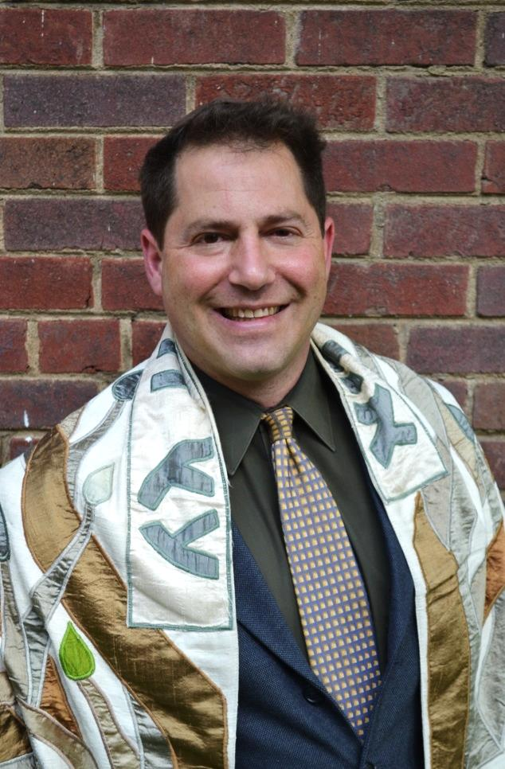
Rosh Hashanah

We welcome the new year with familiar prayers, new songs, and a new set of reflections on life and spirit.

Sunday, September 9, 7:30 p.m. Erev Rosh Hashanah

Monday, September 10, 9:30 a.m. Rosh Hashanah

Tashlich to follow after services at the stream by the Whole Foods parking lot.

Yom Kippur

Tuesday, September 18, 6:00 p.m. Kol Nidre and Erev Yom Kippur

We begin Yom Kippur with silence and the lighting of individual memorial candles at 5:30 p.m. Please be in the sanctuary at 6:00 p.m.; no one will be admitted to the sanctuary during the recitation of Kol Nidre until it has concluded.

Wednesday, September 19, 9:30 a.m. Yom Kippur Day

We continue our personal and communal reflections on teshuvah/returning and nurturing Jewish spiritual ideals.

- 12:00 p.m. Yizkor service
- 1:30 p.m. Study of the Book of Jonah, Martyrology and Avodah Service
- 3:30 p.m. Open discussion / break for those who wish to take a meditative walk)
- 5:00 p.m. Mincha (afternoon) Torah Service
- 5:45 p.m. Ne’ilah – closing service. Final sounding of shofar at 7:00 p.m.

